$$K-means evaluation$$

$$There are two question we need to ask ourslef$$

$$1. How many clusters we need to choose$$

$$2. is the observation belongs to grouped cluster or not$$

$$As we know alreday k=number is a hyper parameter$$

$$which gives the number of clusters$$

$It is very important how to choose good clusters$

$Choosing maximum clusters and choosing minimum clusters not an effective way$

$we need to choose optimal clusters$

$Within cluster sum of squares \left(WCSS\right)$

$elbow method$

$silhouette score$

$Heirarchical cluster$

$$Imagine that we have 10 observations$$

$$How many clusters are possible : 10 clusters$$

$Every observations consider as one group$

$$How many minimum clusters: 1 cluster$$

$All the observations together as one cluster$

$cluster is not good$

$$spread ness is more$$

$$the observations are not tightly together$$

$$the distance between each observation to the means point is more$$

|  |  |  |
| --- | --- | --- |
| Id | X | Y |
| 1 | 1 | 2 |
| 2 | 2 | 3 |
| 3 | 3 | 4 |
| 4 | 4 | 5 |
| 5 | 5 | 6 |
| 6 | 6 | 7 |
| 7 | 7 | 8 |
| 8 | 8 | 9 |
| 9 | 9 | 10 |
| 10 | 10 | 11 |
| 11 | 11 | 12 |
| 12 | 12 | 13 |

|  |  |
| --- | --- |
| K | wcss |
| 1 | W1=5000 |
| 2 | W2= 2000 |
| 3 | W3=1000 |
| 4 | W4=700 |
| 5 | W5=600 |
| 6 | W6=550 |
| 7 | W7=520 |

W1>w2>w3>w4>w5>w6>w7

The deviation between w1 and w2 is so high

Compare to w2 and w3

After some clusters w6 is almost equal to w7

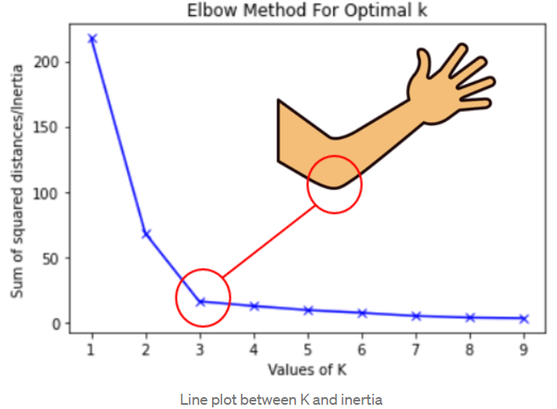

|  |  |  |
| --- | --- | --- |
| Id | X | Y |
| 1 | 1 | 2 |
| 2 | 2 | 3 |
| 3 | 3 | 4 |
| 4 | 4 | 5 |
| 5 | 5 | 6 |
| 6 | 6 | 7 |
| 7 | 7 | 8 |
| 8 | 8 | 9 |
| 9 | 9 | 10 |
| 10 | 10 | 11 |
| 11 | 11 | 12 |
| 12 | 12 | 13 |

|  |  |  |
| --- | --- | --- |
|  |  |  |
|  |  |  |
|  |  |  |
|  |  |  |
|  |  |  |